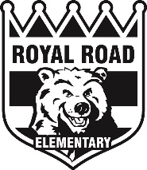Cross Country Running-Fall 2019

Dear Parents/Guardians,
Your grade 3, 4 or 5 child has the opportunity to participate in cross country this fall. Practices will be held on Mondays, Tuesdays and Fridays during lunch hour, where students are expected to attend to be better prepared for the meets. Meets will be held every Wednesday afternoon.
Here are the following meets for the fall:

2019- Cross Country Dates
Date | Northside Location
Wednesday, September 18th | Henry Park
Wednesday, September 25th | McAdam Avenue
Wednesday, October 2nd | O’Dell Park
Wednesday, October 9th  (Rain date-October 16th) | District Finals  Naasis Middle School

*Please stay tuned for cross country updates*

Transportation is not provided and is therefore up to the parents/guardians to make arrangements. Cross country will begin at 1:15 pm SHARP and end at approximately 2:15 pm. Please make sure your child has appropriate footwear and clothing (ex: sneakers only and shorts/jogging pants). We will be providing Royal Road shirts, but we ask that they are returned at the end of each meet.
We will meet the students at each cross country site at 1:00.

If you have any questions please do not hesitate to ask. See you there!

Mr. Sidik, Mrs. Woodley and Mrs. Waterhouse

